**Assignement 4 Report**

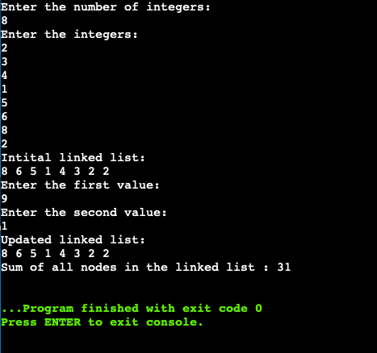

I have used an online compiler because my MacBook compiler cannot support the insertion of header inside cpp. I have provided comments in the code.